Ethics and AI in Education

Jonathan Tsui Marin Aske Miguel Castellano
Information Technology Information Technology Information Technology
University of Central Florida University of Central Florida University of Central Florida
jo828171@ucf.edu ma617209@ucf.edu mi437753@ucf.edu

Abstract: Artificial Intelligence (AI) is growing rapidly in the field of education, especially following the COVID-19 pandemic, which forced the adoption of AI tools for teaching, monitoring, and personalized learning. While AI offers many benefits including accessibility, efficiency, and personalized learning, it also raises issues ethically, socially, environmentally, legally, and health related. This paper explores the impacts of AI in education, emphasizing the ethical side of this growing technology. Ethical challenges include data privacy, lack of human interaction, algorithmic bias, and inequitable access. Overall, this paper argues that AI can serve as an innovative tool for education but also needs to be implemented with fairness, security, transparency, and be in the healthy use of humans, rather than damage the learning experience.

Introduction

AI is a newly rising tool used in education today. From all levels of education, we are starting to see AI increasingly in the classroom. Whether it is being used as a tool by teachers, or being used as a tool by the students, since the Covid pandemic, we have seen a larger adoption of AI to make education easier and more efficient for all parties involved. The ethics of the widespread adoption of AI in our education is paramount. The factors that we need to consider include fairness, safety, access, and the influence of these tools shaping the future of learning. When used as a tool to complete assignments, AI tools such as ChatGPT and DeepSeek may omit specific information that could be essential to getting the full picture in specific topics pertaining to specific subjects. An overdependence on AI tools can make students lazy. There is a large issue right now on college campuses where students will just copy and paste their entire assignments into AI tools such as ChatGPT and DeepSeek, get the answers and turn them in without learning anything. This can lead to a low skilled technical workforce.
In 1950, renowned mathematician and computer scientist Alan Turing created the Turing Test, which serves as a test to determine whether a machine can exhibit human-like intelligence through conversation. In 1966, Joseph Weizenbaum created the world's first chatbot during his time at MIT. This chatbot simulated a psychotherapist using pattern recognition skills to return user statements back to the user as questions. This created an illusion of empathy and understanding at the computer level. In the 1990’s, AI was incorporated into adaptive testing and basic tutoring systems. The first Online-Learning Platform was released to the public and used to present learning programs to students. In the 2010’s, natural language processing enabled automated grading, essay feedback and chatbots that could be used to answer questions that the user needed clarification on. These technologies led to the widespread adoption of AI driven personalization on these tutoring systems. In 2020, the Covid-19 pandemic became a major influence in mass adoption and widespread use of these AI programs in education. Due to the lack of face-to-face connections, more online learning tools such as proctors were adopted to act as a teacher at home and cut down on cheating in courses.
In Section II we cover the technical aspects of AI use in education. In Section III, we will cover the social impacts that may arise during the expansion of AI use in education. In Section IV, we will cover the professional impacts of AI use in education for the workers that will be affected. In Section IV.A we will cover the career paths associated with the change in education to use AI tools. In Section IV.B, we will cover the job projections and see how the job market will change with the adoption of AI in education. In Section V, we will cover the ethical issues that need to be accounted for as the AI tools become synonymous with education. In Section VI, we will cover the environmental issues that can arise by increasing AI use in terms of education with things such as power usage and technical waste. In Section VII, we cover some of the legal issues that can arise from the evolution of education over time after the adoption of these new tools into the everyday curriculum. In Section VIII, we cover the health issues that can come because of prolonged technology usage, especially with how it affects younger minds that are now being tasked to rely on it. Lastly, in Section IX, we have our final remarks on the topic where we will tie everything together.

Technical Aspects

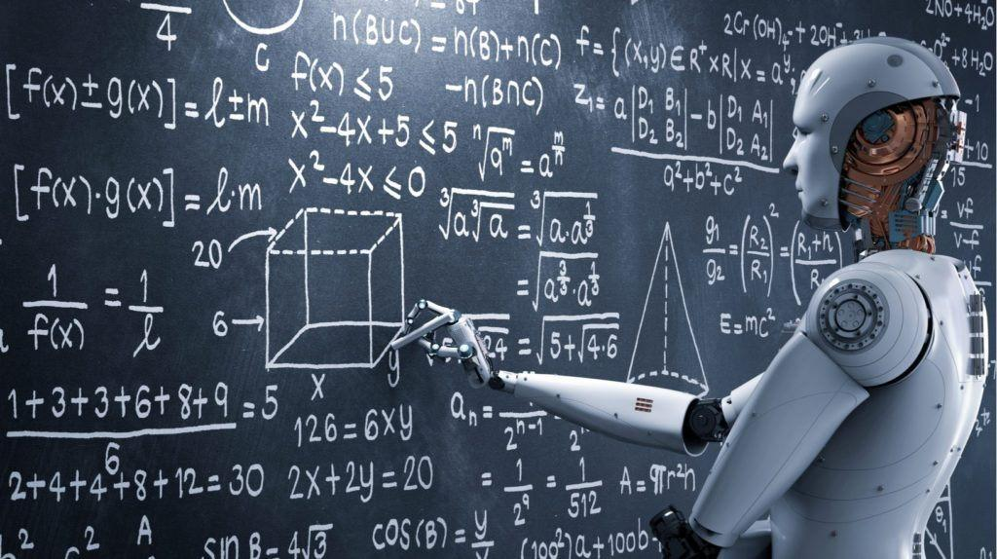

Figure I: Representation of what classroom settings may look like with AI expansion.
AI in education uses a multitude of technologies to work properly. Aspects such as Machine Learning Algorithms, Natural Language Processing and Recommendation Engines are used to train these new wave AI models. AI needs to be trained and tailored depending on what field it is being used in, and education is no different. Natural Language Processing also helps these AI models to take in natural languages and interpret them to tailor a proper response based on the user input. Recommendation engines also work to recommend answers based on the best available response.
Figure I represents what the future of education would look like. Some examples of AI being used in the education system include automated grading systems, chatbots, and personalized learning systems. Automated grading systems are used nationwide in the United States. The answers are input by the professor or instructors, and the grades are compiled automatically using the answer keys. Chatbots are used in education to answer questions or give insight into problems that may arise during education. Lastly, personalized learning systems are tutoring systems that tailor the lesson plans based on the user itself, allowing for these systems to make a lesson plan that can focus on topics that the user is struggling with to try and compound the knowledge into the user.

Social Impacts

AI’s social impacts can be categorized into two categories, positive and negative. In terms of the positives, AI can help democratize education, making it more accessible and equitable for all people, regardless of their background. There is also a positive increase in accessibility for disabled students. Students that have mental or physical disabilities can now learn at the same level as other students using tools that allow them to fully practice and grasp the topics in unconventional ways. Lastly, AI has allowed for a major improvement in language translation in the education system.
The negatives on the other hand can be very detrimental to the education of students all around the world. AI can bring a digital divide, which is explained as unequal access, benefits, and opportunities. This can also lead to over-dependence on AI tools. Especially in technical industries, students who have spent their entire lives using AI to “learn” things will need to deal with these tools for the rest of their life due to their lack of understanding of core and technical concepts. This leads to a low-skilled workforce that must rely on AI to get menial tasks in the workforce completed on time. Lastly, there is a reduction in human interaction. Students who rely mostly on AI to collaborate with will suffer when it comes to learning how to work together with other humans, leading to a major skill gap in the education system.

Professional Impacts

Trust & Public Confidence – Ethical AI practices foster public trust, making consumers and stakeholders more likely to adopt AI-driven solutions across industries like healthcare, finance, and education. Workforce & Skill Demand – The rising need for AI ethicists, policy advisors, and educators is shaping new career paths at the intersection of technology, philosophy, law, and social sciences. In healthcare, this means ensuring that diagnostic algorithms are free from biases that could lead to unequal treatment for marginalized populations, and that patient data remains secure. In finance, it involves proactively auditing lending or credit-scoring models to prevent discriminatory outcomes, thereby avoiding legal and reputational damage. This focus on responsible development is the direct catalyst for the new, specialized workforce demand. The AI Policy and Governance Specialist is vital, acting as a bridge between technical teams and regulatory bodies. They translate abstract ethical principles into concrete compliance frameworks, ensuring that internal AI practices meet external legal obligations, such as data privacy laws. Simultaneously, the AI Engineer’s job has evolved to be inherently ethical, as they are now tasked with incorporating fairness-aware algorithms and bias testing directly into the code—moving ethics from an oversight function to a foundational part of the development lifecycle.

Careers

The field of Artificial Intelligence offers several critical career paths focused on ensuring ethical, fair, and responsible deployment of AI systems, as well as developing the technology itself and educating future professionals. These roles command competitive salaries, ranging from $65,000 to $180,000. These positions, salaries, and job descriptions are listed in table 1.
Table 1: Potential job positions in Ethics and AI Education.
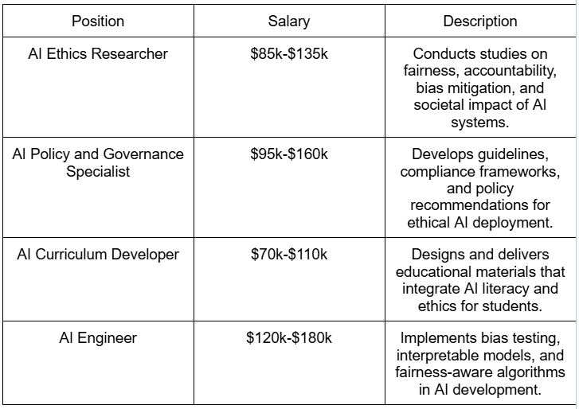

B. Job Projections
The demand for AI and ethics expertise is accelerating as industries adopt AI more widely while facing public scrutiny and regulatory oversight. The global Ethical AI Education & Training market is projected to grow from around $1.2 billion in 2023 to $6.5 billion by 2030, reflecting rising institutional and corporate investments. Workforce studies project that AI-related jobs explicitly requiring ethics and governance expertise—roles such as AI Policy Specialist and AI Ethics Researcher—are set to increase by over 30-40% by the year 2030. This growth is driven by the necessity for companies to manage algorithmic risk, ensure compliance with evolving frameworks (like the EU's AI Act), and transform abstract ethical principles into practical, auditable engineering practices. In parallel with this corporate demand, the entire educational ecosystem is undergoing fundamental restructuring to meet future skill requirements. Educational efforts now focus on teaching students to use AI tools critically, recognize and mitigate inherent biases, and uphold principles of accountability and fairness, ensuring that the next generation of developers and users are equipped to build and consume AI responsibly.

Ethical Issues
Many ethical issues occur in AI in education, one of those is how AI can easily be biased and unfair to certain students. For example, if AI is trained off data of real-world inequalities or trained to grade certain test scores like correctness over creativity in a writing paper it can be heavily biased in certain ways. The way to fix this is to train AI in these diverse populations and trained in ways to identify success in all ways a regular grader would grade. This also leads to someone who makes mistakes if AI makes a mistake or clearly is biased. Who should be accountable in this case? The school, AI developer, government, or teachers at the school? This is a large ethical issue because a simple mistake AI makes towards a student could lead to many legal issues throughout the system. The use of AI can lead to ethical issues if parents are okay with students learning from AI and not human teachers, and what effect would this have on the students to not having teacher interaction. Teachers provide a lot of emotional support, and help develop social skills in students, which is much more than just teaching the class a topic but also how to behave socially. Another ethical issue is data privacy. With AI in education, they will need to be transparent on what information AI has access to and who has access to it, especially with personalized learning students may end up sharing a lot of information for best learning experience which can lead to a lot of data leaks or other issues. Finally, accessibility and equality issues can occur when AI is implemented into school systems. Some students may exist where they do not have funds for purchasing internet or certain devices making inequalities even bigger.

Environmental Issues
AI in education can cause a variety of environmental issues, the most notable is its energy consumption. AI like Chat GPT uses five times more energy to perform a query than a regular google search. If you think about millions of students using technology like this every day for hours, it can add up fast. Training OpenAI's GPT-3 took 1,287 megawatt hours of electricity, which is enough to power 120 average U.S homes for a year [1]. This generated 552 tons of carbon dioxide. This shows how much electricity we used compared to daily activity electricity usages we “need” more so. In 2023 3.85 million GPUs were shipped to data centers from AMD, Nvidia and Intel, which is up from 2.67 million in 2022 [2]. There are many promises to be carbon neutral by 2030, but these companies show no evidence supporting this claim and are using more energy than before every year. In Table 2 we can see the future of these big companies and what they do and are promising for environmental changes.
Table 2: Amazon, Microsoft, and Google’s plans to be sustainable.
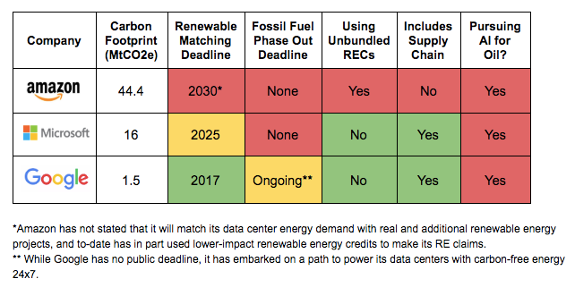

Legal Issues
There are many legal issues with Ethics and AI education, the main one being data protection. Many data privacy rights and acts could be easily violated. For example, FERPA, which stands for Family Educational Rights and Privacy Act which protects student’s records like GPA, family contact information, course schedule, disciplinary action records, and more. The COPPA (Children’s Online Privacy Protection Act) is also an act that deals with data privacy to websites that target under 13 years old children. This act enforces parental consent to gather data and lets parents delete data if wanted. It also enforces websites to not ask for more personal information than for what is needed for the activity. Another legal issue that can occur in AI in education is accountability, who should take legal accountability if AI were to make an error. An error could lead to defamation, negligence, or discrimination. Since there is not a set education law caught up with AI technology, these accountability issues will come up soon where we must decide who takes blame, the teacher using AI, the school or district, or the AI developer itself. With these points we must find a way to integrate legal systems and values into how we will use AI in education, so it is both ethical and does not violate any laws or personal information.

Health Issues
With AI being in education students and teachers may end up using this technology at least 6-8 hours a day, and this can bring out a lot of health-related issues with both students and teachers. The long hours using AI can lead to eye strain and physical fatigue, screen time from using AI can lead to eye strain, headaches, blurry vision, and more. This also means they are in a stationary position like sitting down for hours staring at the computer which could lead to fatigue or other physical related problems like posture issues. In Covid-19 AI played a huge role in education because it forced remote learning. Before the pandemic we used AI mostly optionally as an add-on if you chose to but when schools were forced to close AI it became a necessity to maintain teaching at the same pace as we would in school teaching.

Final Remarks
AI can be used as an incredible tool to advance education around the world, but can also serve as a roadblock, especially for advanced education. AI can be great when used as a tool. It can brainstorm, give explanations, and help students that need extra resources to become successful in the education systems. These AI tools can also be unreliable and show biases that are suboptimal when applied to education. Some of the issues that we can expect to run into are ethical issues such as accessibility inequality, data privacy, lack of human interaction, and bias at the hands of these AI tools. Also, the environment will be affected by the increased demand for these AI tools. AI models will negatively impact the environment unless regulated. We can also expect some legal issues surrounding the ideas of data protection, potential violations of FERPA, as well as the Protection of Pupil Rights Amendment, and lastly accountability. We can also predict some health issues because of AI adoption. The demand of being on screen can lead to increased eye stress on students, a decrease in social growth due to the decrease of human interaction in schools, and mental stress brought on by a lack of communication and collaboration with others. Especially at the High School and College levels where students are in their final push for developing as adults, the lack of human interaction can lead to a massive disconnect, creating issues in their post-graduate and professional lives.

References
[1] Zewe, A. (2025, January 17). Explained: Generative AI’s environmental impact. MIT News. https://news.mit.edu/2025/explained-generative-ai-environmental-impact-0117

[2] United Nations University & International Telecommunication Union. (2024). The Global E-Waste Monitor 2024 – Electronic waste rising five time faster than documented e-waste recycling. E-Waste Monitor. https://ewastemonitor.info/the-global-e-waste-monitor-2024/

Tables
[2] Eaton, C. (2020, January 27). Microsoft, Google, Amazon – Who’s the biggest climate hypocrite? Greenpeace USA. https://www.greenpeace.org/usa/microsoft-google-amazon-energy-oil-ai-climate-hypocrite/

